Health Related Components of Fitness
Those factors that are related to how well the systems of your body work.

Component | Definition | Determinants | Tests
Body Composition

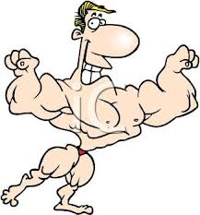

Cardio Respiratory Endurance

Flexibility
Muscular Strength

Muscular Endurance
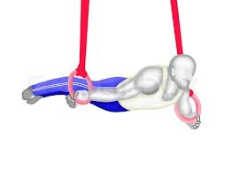

Skill Related Components Of Fitness

These components are extremely important for participation in sports, but they have little significance on a person’s overall health and wellness.
Component | Definition | Determinants | Tests
Power
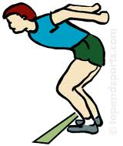

Speed
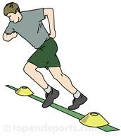
Coordination
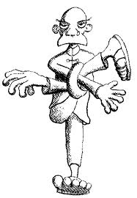
Balance
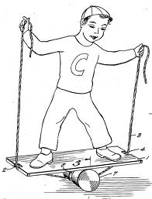
Reaction Time
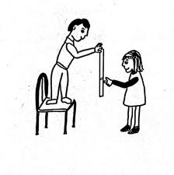
Agility
