Motion Analysis

Step 1: Biomechanical Principles
- How does each principle apply, if they don’t why not?

Step 2: Force Vector Analysis
- Scalar and vector quantities
- Drag forces – friction and profile drag
- Fluid lift forces – Bernoulli’s Principle
- Magnus effect

Step 3: Newton’s Laws
- How do they apply?
- Calculation of forces, velocities and accelerations

Step 4: Identify the “type” of motion
- Linear, angular, or a combination, or projectile

Scalar and Vector Quantities

Scalar quantities have only magnitude (numerical value).
example: time

Vector quantities have both magnitude and direction.
example: distance, force

Vectors are represented by straight-line arrows. Tip (head) of the arrow points in the direction of movement.
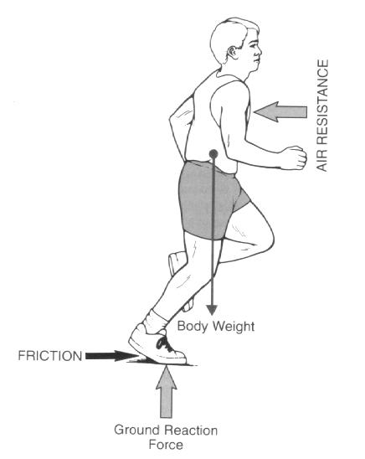
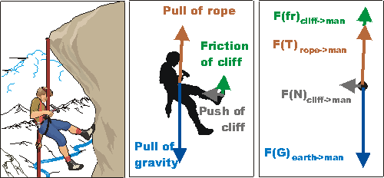

Drag Forces

- Friction Forces – a force that resists the motion between two objects. Examples include air, skin (fluid layer on skin), ground, etc.

- Profile Drag – air flows past objects and collects behind the object creating a low pressure zone that has to be pulled along, making it more difficult to move.

Fluid Lift Forces (Bernoulli’s Principle)

The movement of objects through a fluid (air, water) generates forces that can move the object. Javelin uses the lift force to travel further in the air. Racecars are designed to force them downward to maintain contact with the racetrack. Sailboats use a sideward force to propel them forward.

Bernoulli’s Principle describes the relationship between the opposing forces as an object moves through a fluid.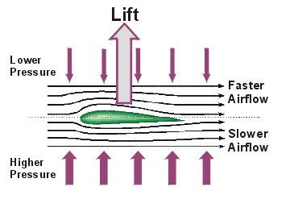
Higher speed creates low pressure.
Lower speed creates high pressure.

Therefore for an object moving through a fluid the motion is determined by the sum of the forces acting upon it.

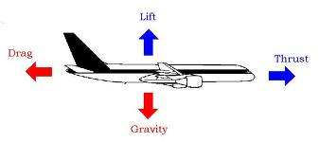

Thrust force is the force propelling the object forward.

Lift force is the upward force generated by the differences in fluid pressures.

Gravity is the force pulling an object towards the Earth.

Magnus Effect

The Magus Effect is the ability to alter the course of an object based on the direction of spin of the object. The spinning of the object generates differences in pressures on opposite sides of the object. The object will move in the direction of high to low pressure. This is an extremely important skill in many sports.

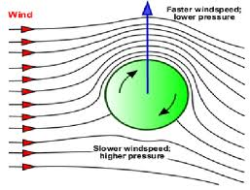

Top Spin – reduces the horizontal distance with no loss in takeoff velocity

Back Spin – increases the horizontal distance, time in the air for a given take off velocity

Side Spin – will curve the ball to the spinning side

Projectile Motion

Any airborne object is in projectile motion.

The centre of mass follows a parabolic path.

Objectives of Projectile Motion:

1. maximum vertical distance (height)
2. maximum horizontal distance (range)
3. accuracy

To get maximum height, (high jump) you must maximize the take velocity and maximize the take off angle.

To get maximum distance, (long jump) you must maximize the take velocity and take off at an angle of 45 degrees to the horizontal.

