History Of Atomic Theory

300 B.C. – Democritus coined the term “atom” to refer to the smallest indivisible particle of matter

1809 – John Dalton – Billiard Ball Model

Dalton’s Atomic Theory
- All matter is composed of tiny particles called atoms
- Atoms can be neither subdivided nor changed into one another
- Atoms cannot be created or destroyed
- All atoms cannot created or destroyed
- All atoms of one element are the same in shape, size, mass and all other properties
- Chemical change is the union or separation of atoms
- Atoms combine in small whole-number ratios such as 1:1, 1:2, 2:3, etc

Dalton’s “Billiard Ball” Model

Dalton’s theory explained three important laws. (Table 1, page 162)
Dalton’s theory did not explain the subatomic particles that were found later.

1897 – J.J. Thomson – Raisin Bun Model

- built on the works of earlier scientists and the development of technological devices
- see Table 2, page 163
- used cathode rays to bombarded the atom with alpha particles (positively charged particles)
- It was expected that the alpha particles would travel straight through instead they scattered

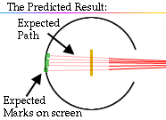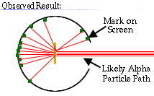

Thomson concluded that the atom was not the smallest particle; there are subatomic particles in an atom.
His proposed the atom is a sphere of uniform positive electricity in which negative electrons ere embedded.

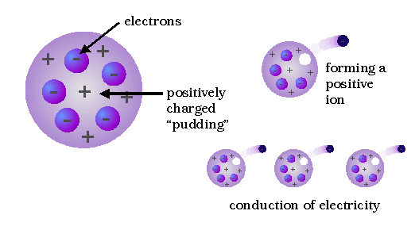

1911- Ernest Rutherford – Beehive Model

- Discovered that radium emits three different types of radiation (alpha, beta particles and gamma rays)
- Alpha particles are Helium nuclei (2 protons and 2 neutrons)
- Gold Foil Experiment
- Directed alpha rays at a thin piece of gold foil
  - Based on Thomson’s model the rays should deflect little if not at all
  - Found that most passed through, some were deflected, some reflected back
  - Since opposite charges repel there must be a positive charge in the center of the atom

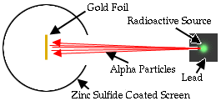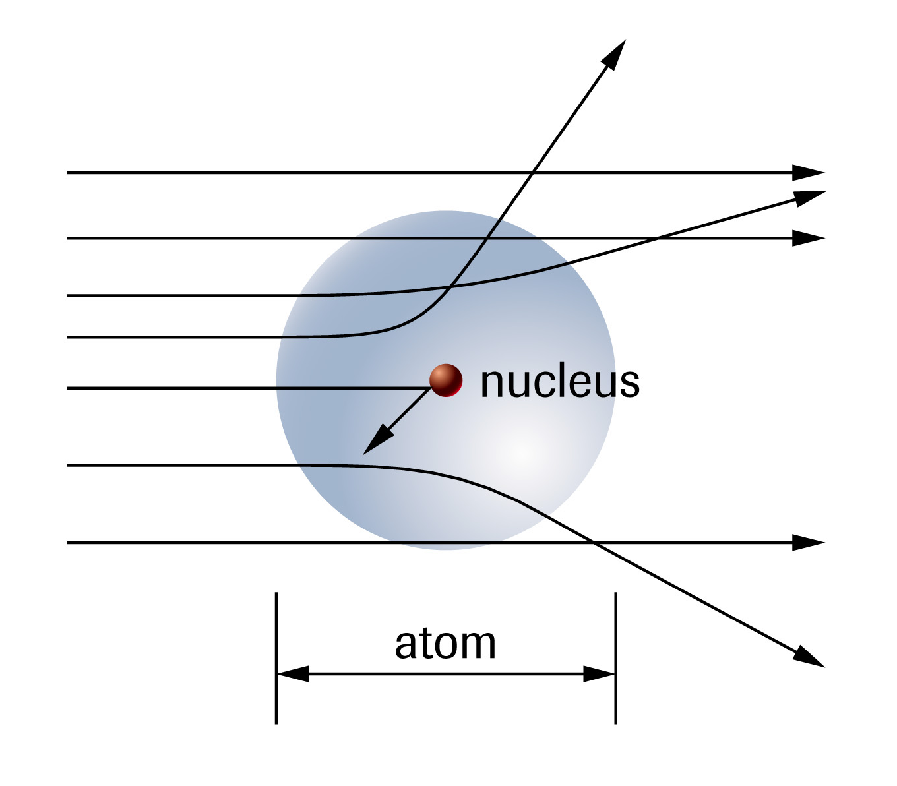

Rutherford concluded the mass and positive charge of an atom is concentrated in a very small region, and most of the atom is empty space. (See Table 3, page 164)

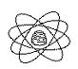
Rutherford’s Beehive Model

Further research described the proton as the smallest positive charge. Its charge was equal to but opposite that of the electron. Its mass was 1836 times the mass of the electron.

Rutherford”s model fail to explain why the atom does not collapse. When the electrons in continuous motion they should be emitting electromagnetic radiation and losing energy which would collapse the atom. However, this does not happen.

Answer page 166 # 3,4,5

1900 – Max Planck – Quantum Theory

- atoms absorb or release energy in discrete packages called quantum and in terms of light are referred to as photons
- as a solid is heated to higher temperatures they begin to glow: red then white (all colours) then blue
- studied the light emitted by blackbodies (perfectly black object that does not reflect any light and emits various lights as a result of its high temperature)

Examples of Blackbodies
- Stove element red hot
- Light bulb filament white hot

- Planck explained that the light emitted by a hot solid occurs as bursts of energy (quantum) and not in a continuous stream
- E = hf
- The Photoelectric Effect the release of electrons from a substance due to light striking the surface of a metal
- Einstein used Planck’s idea of photons to theorize that the photon strikes the electron passing its energy to the electron
- The electron uses the energy to break free of the atom and be ejected
- There is a minimum quantity of energy need by the electron to break free
- Add Figure 6, page 172 to explain the energy need to eject an electron from a solid

Answer page 173 #6, 7

Electromagnetic Spectrum

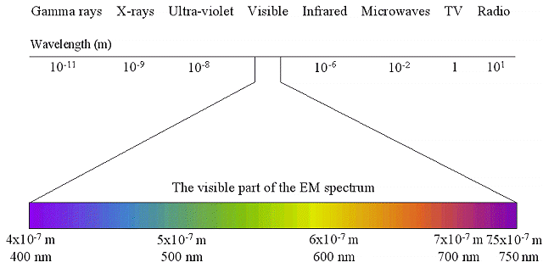

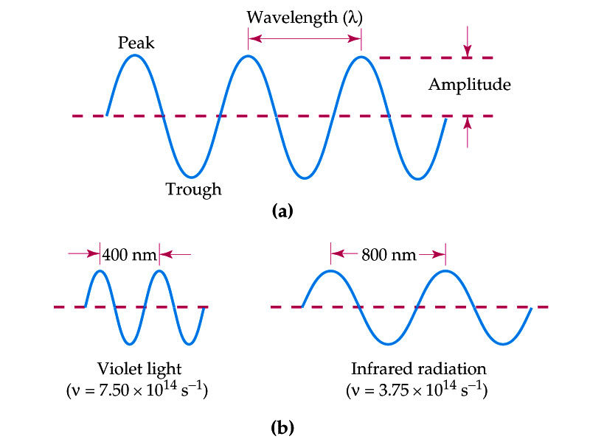

Review:

- Radiation with shortest wavelength is ______________ and the one with longest is __________
2. Microwaves have a _____________ wavelength than x - rays
3. Infrared has a _____________ frequency than visible light
4. Visible light represents a ______________ spectrum with the colours ROYGBIV arranged in order of ____________ wavelength and _______________ energy.

1913- Neils Bohr – Solar System Model

- proposed a model based on quantum mechanics
- used spectroscopy to analyze the bright-line/ dark-line spectrum produced by a hydrogen atom

- Postulate #1: electrons do not radiate energy as they orbit. Each orbit corresponds to a state of constant energy. (Stationary or ground state)

- Postulate #2: electrons can change their energy only by transition from one stationary state to another. Photon is absorbed when the electron “jumps” to a higher state and a photon is released when an electron “drops” from a higher state

Bohr Model Video
http://www.youtube.com/watch?v=CUk3enr-m0w

- Bohr’s model described the specific positions and behaviours of electrons in the atom
- Electron orbits are at fixed distances from the nucleus
- Each orbit represented a fixed amount of energy
- Orbit (n=1) closest to the nucleus had the lowest amount of energy
- An electron receiving a quantum of energy that allowed it to “jump” to the next orbit was unstable and would drop back to its ground state releasing the energy
- The energy released would be seen by the spectroscopy as a band of light

Weaknesses of the Bohr Model

- works for only 1 electron systems
- failed to explain the line spectrums observed with other elements

1924 – Louis de Broglie

- suggested a dual nature, the electron has both particle-like and wave-like characteristics

1926 – Werner Heisenberg

- Uncertainty Principle it is impossible to know both the position of a particle and its speed/direction at the same time

Modern Atomic Theory Video
http://www.youtube.com/watch?v=cy2rEt63Af4

1926 – Erwin Schrodinger

- used the “electron wave” idea to develop our present orbital theory of the electron
- orbitals or electron clouds are where there is a probability of finding an electron
- orbitals take on certain shapes or sublevels (s-spherical, p-hourglass, d-cloverleaf, f-8 lobes)
- the energy level, n, must equal the number of sublevels
- within a sublevel the number of orbitals will change
- for the s – sublevel there is 1 orientation; for the p – sublevel there are 3; for the d – sublevel there are 5; for the f – sublevel there are 7

1932- James Chadwick

- used alpha bombardment to explain why the mass of the nucleus was not equal to the number of protons
- discovered the neutron (a neutral particle of equal mass to a proton)

Electron Configuration
http://www.youtube.com/watch?v=MJLYBbNGSIw
http://www.youtube.com/watch?v=gcgbGwdAh-s

Quantum Numbers
http://www.youtube.com/watch?v=oK6K68ADKDA

