The Structure and Properties of Solids

- Solids (element or compound) have common characteristics such as compressibility and viscosity
- Differences in characteristics include hardness, melting point, mechanical characteristics and conductivity
- The differences are due to the differences in the forces between molecules

Classification of Solids
Classification | Elements combined | Example
Ionic | Metal + non-metal | NaCl
Metallic | Metal(s) | Cu, CuZn₃
Molecular | Nonmetal(s) | I₂, H₂O
Covalent network | Metalloids/carbon | C, SiO₂

Ionic Crystals

- Ionic compounds form crystal lattice structures
- Large variety of shapes
- Relatively hard but brittle solids
- Conduct electricity in liquid state but not as a solid
- High melting points

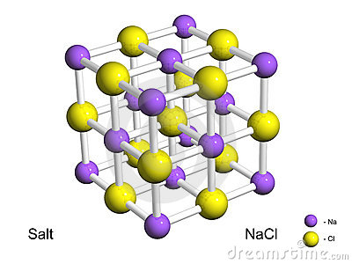

Diagram: Salt crystal – alternating positive and negative charged ions
Metallic Crystal

- Metals have a continuous compact crystal structure
- Properties are the result of bonding between fixed positive nuclei and mobile “loose” valence electrons

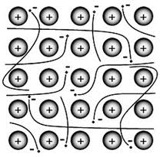

Diagram: Metallic Bonding – a sea of negative electrons flowing freely amongst positive nuclei

Explaining Metal Properties
Property | Explanation
Shiny, silvery | Valence electrons absorb and re-emit the energy from all wavelengths of visible and near-visible light
Flexible | Nondirectional bonds mean the the planes of atoms can slide over each other while remaining bonded
Electrical conductivity | Valence electrons can freely move throughout the metal; a battery can force additional electrons onto one end of a metal sample and remove other electrons form the other end
Hard solids | Electron sea surrounding all positive centres producing strong bonding
Crystalline | Electrons provide the “electrostatic glue” holding the atomic centres together producing structures that are continuous and closely packed
Molecular Crystals

- Examples: iodine, sulphur, ice, solid carbon dioxide, waxy solids (large hydrocarbons), polymers (plastics)
- Generally, low melting points, not hard, do not conduct electricity
- Molecules are arranged in a crystal lattice structure
- Only intermolecular forces are Van der Waals
- Thus very weak forces

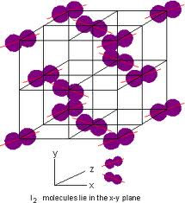

Diagram: Iodine Molecular Crystal
Covalent Crystals

- Examples: diamond, quartz, graphite
- Massive aggregates of atoms covalently sharing electrons
- Generally contain carbon and/or silicon
- Tend to be exceptionally hard, have high melting points, insoluble in water

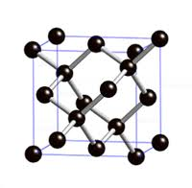
Diagram: Diamond – each carbon atom makes four linkages. The four C-C bonds are of equal strength. Strength of diamond makes it useful component of cutting tools.

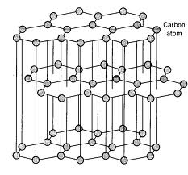

Diagram: Graphite – uses only 3 linkages to other carbons. Therefore, there are layers of carbons that are not bonded. Unused electrons are free to move throughout the layers. Allows graphite to conduct electricity. Allows the layers of graphite it glide over each other. Graphite is useful as a lubricant and in pencils.

